**MAHARASHTRA STATE BOARD OF TECHNICAL EDUCATION, MUMBAI**

Shri Vishweshwar Shikshan Prasarak Mandal’s

# Vishweshwarayya Abhiyantriki Padvika Mahavidyalaya, Almala

Certificate

This is to certify that Mr. Mashale Soham Kiran, a student of our institute in the **Third** year **Computer Engineering (CO3I),** has successfully completed the micro project report on **“DBMS Microproject”** for the course **“DBMS”** as part of the curriculum prescribed by the Maharashtra State Board of Technical Education, Mumbai.

For partial fulfillment of “**Diploma in Computer Engineering**” during the academic year 2022-23.

GUIDE HOD

Mr. Lokare A. P. Mr. Kazi A. S. M.

PRINCIPAL

Mr. Dharashive P.S

**MAHARASHTRA STATE BOARD OF TECHNICAL EDUCATION, MUMBAI**

Shri Vishweshwar Shikshan Prasarak Mandal’s

# Vishweshwarayya Abhiyantriki Padvika Mahavidyalaya,

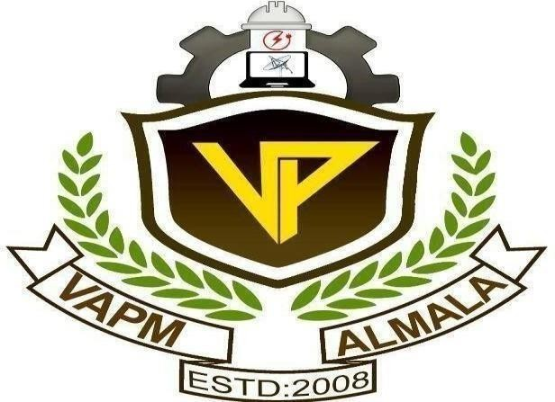Almala.

Department of Computer Engineering Academic Year-2022-23

Micro-Project Report On

**“DBMS Microproject”**

Submitted By

Enrollment No Name of Student

2210950166 Mashale Soham Kiran

Under the Guidance of

Mr. Lokare A. P.